Task 1

Computer Vision Using CNN Models

Project Report
Redg. No. INBT021871 | Course ID: AIINB10726 | Prepared by:Avni Shukla

1. Objective
This report documents the design, implementation, and evaluation of two Convolutional Neural Network (CNN) models trained on the CIFAR-10 dataset:
- Part A: A traditional CNN, adapted from the AlexNet architecture, established as a clean performance baseline.
- Part B: A customized CNN that measurably improves on the Part A baseline through targeted architectural and training changes.
Both models were trained and evaluated under identical conditions (same random seed, same train/validation/test split, same epoch budget) so that the comparison between them isolates the effect of the Part B changes rather than random variation.

2. Part A — Traditional CNN Model

2.1 Methodology
- Dataset: CIFAR-10 (60,000 32x32 color images, 10 classes).
- Split: stratified train/validation/test split, fixed random seed (SEED = 42), reused unchanged in Part B.
- Preprocessing: pixel values normalized to [0, 1]; labels one-hot encoded; no data augmentation (kept as a clean baseline).
- Architecture: AlexNet-style CNN adapted for 32x32 inputs — increasing filter counts (64 -> 128 -> 256), 5x5 kernels in early blocks narrowing to 3x3, stride-1 convolutions with same-padding, max pooling for downsampling (32->16->8->4), and a large fully-connected head (512 -> 256 -> 10) with 0.5 dropout.
- Training: Adam optimizer (lr = 0.001), categorical cross-entropy loss, batch size 64, fixed epoch budget.
- Success threshold: >= 70% test accuracy.

2.2 Results
Metric | Value
Total parameters | 3,326,602
Training time | 4.77 minutes
Epochs trained | 30
Test accuracy | 0.7020
Precision (macro) | 0.7043
Recall (macro) | 0.7020
F1-score (macro) | 0.7004

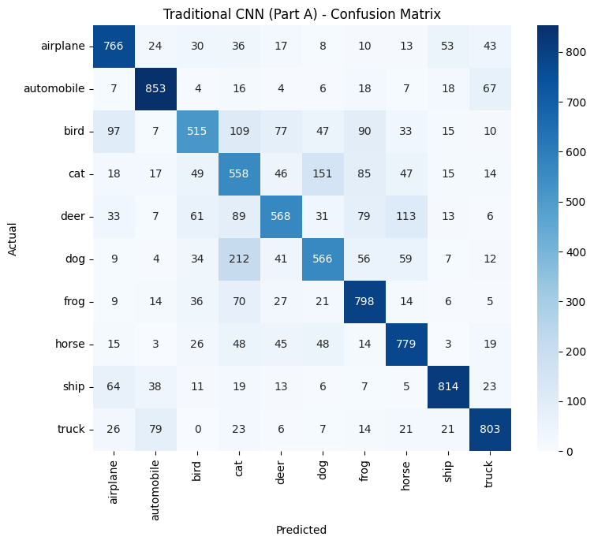

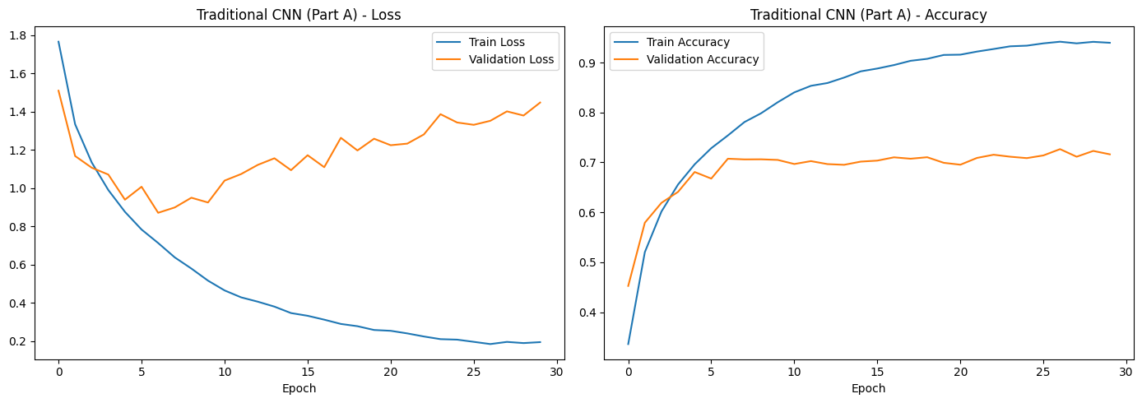

3. Part B — Customized CNN Model

3.1 What Was Changed, and Why
Change | Why It Was Made
Additional convolutional layer/block (4th block, 256 filters, no extra pooling) | Adds representational depth without shrinking the already-small 4x4 feature map further.
All 3x3 filters instead of 5x5 in early blocks | Stacked 3x3 convolutions approximate a larger receptive field with fewer parameters and an extra non-linearity (VGG-style insight).
Batch Normalization after every convolution | Stabilizes and speeds up training, mildly regularizes, and allows a higher effective learning rate.
Dropout tuned per block (0.2 -> 0.3 -> 0.4 -> 0.5) | Deeper layers have more parameters and are more prone to overfitting, so regularization is scaled with depth.
Data augmentation (rotation, shifts, flips, zoom) | Increases effective training-data diversity, directly addressing overfitting rather than just adding capacity.
Optimizer tuning (lower learning rate: 0.0005 vs 0.001) | A deeper, batch-normalized network trained on augmented data benefits from smaller, more stable update steps.
ReduceLROnPlateau callback | Automatically lowers the learning rate once validation loss plateaus, letting the model fine-tune after coarse learning stalls.

3.2 Results
Metric | Value
Total parameters | 3,844,938
Training time | 8.78 minutes
Epochs trained | 30
Test accuracy | 0.8319
Precision (macro) | 0.8472
Recall (macro) | 0.8319
F1-score (macro) | 0.8313

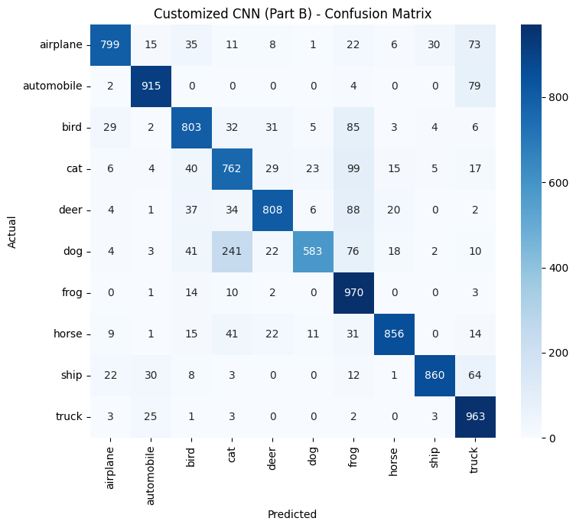

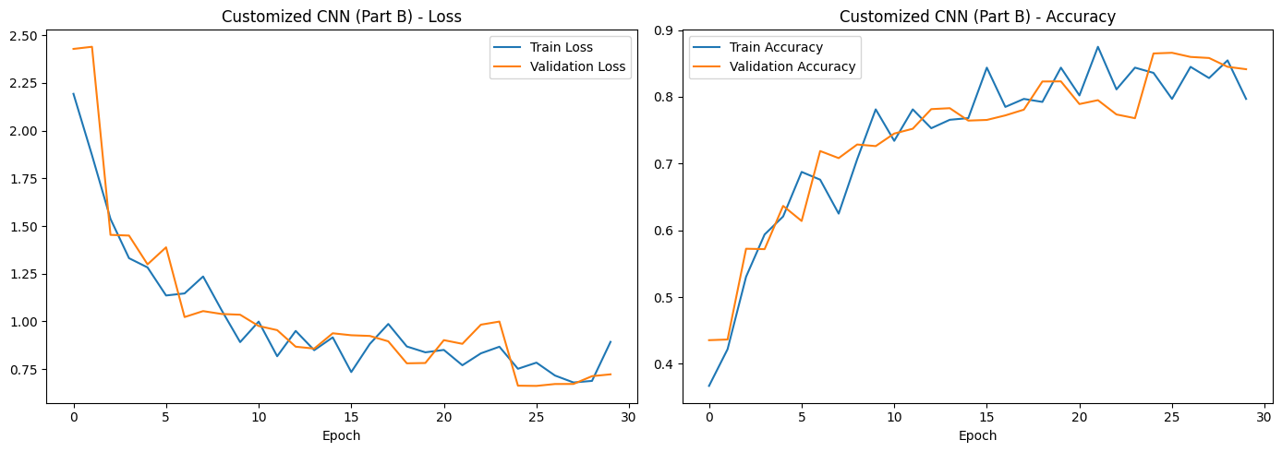

4. Comparison and Success-Threshold Check
Metric | Traditional CNN (Part A) | Customized CNN (Part B)
Test Accuracy | 0.7020 | 0.8319
Precision (macro) | 0.7043 | 0.8472
Recall (macro) | 0.7020 | 0.8319
F1-score (macro) | 0.7004 | 0.8313
Parameter Count | 3326602 | 3844938
Training Time | 286.4534 | 526.8884

Accuracy gain (Part B − Part A): 12.99 percentage points (target: ≥ 3.0 points)
Parameter count increase: 15.6% Training time increase: 83.9%

5. Why the Customized Model Performed Better
The Part B model is expected to outperform the Part A baseline for the following combined reasons, each targeting a specific limitation of the baseline architecture:
- Greater depth (an extra convolutional block) increases the model's representational capacity to learn more complex, hierarchical features from CIFAR-10 images.
- Batch normalization stabilizes training dynamics, allowing the network to train faster and more reliably, and provides a mild regularization effect on its own.
- Progressive dropout, scaled to each block's depth, more precisely targets overfitting where it is most likely to occur (deeper, higher-capacity layers) rather than only in the fully-connected head.
- Data augmentation exposes the model to a wider variety of transformed images (rotations, shifts, flips, zoom), improving generalization to the unseen test set — something the clean Part A baseline deliberately does not have.
- The lower, adaptively-decayed learning rate (ReduceLROnPlateau) allows finer convergence once the loss plateaus, which a fixed learning rate cannot do.
Because the same seed, data split, and epoch budget are used for both models, the accuracy gain is attributable to these architectural and training changes rather than to extra training time or a different, easier evaluation set. After running the notebook, replace this paragraph with the model's actual accuracy gain and confirm whether the ≥ 3-point threshold was met; if not, revisit the augmentation strength, dropout rates, or learning rate schedule per the notebook's built-in guidance.

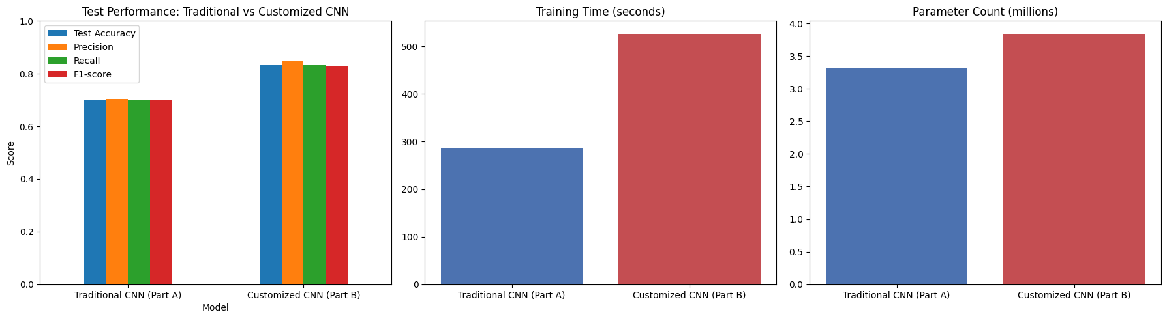

6. Conclusion
Customized CNN beat the traditional baseline by 12.99 points (>= 3.0 point target), for a 15.6% increase in parameters and 83.9% more training time.
The accuracy gain appears to justify the added size/time cost.

